TASK 1 – CLASS DESIGN REVIEW
Bloom’s Level: K5 – Evaluate
Diagnose and Repair Duplicated Classes
6 Marks
A college payroll program has three separate classes written by different developers:
class Professor { public: string name; int id; double basic; double da; double research;
double pay() { return basic + basic * 0.42 + research; } };
class LabAssistant{ public: string name; int id; double basic; double da;
double pay() { return basic + basic * 0.42; } };
class GuestFaculty{ public: string nm; int code; double hours; double rate;
double pay() { return hours * rate; } };

Task 1.1 – Diagnose the Design | 2 Marks
Identify at least five design deficiencies. Examine aspects such as:

• Repeated fields and repeated pay rules
• Public data members
• Inconsistent names for the same information
• The unused da field
• The magic number 0.42
• The effort needed to add a new staff category
• The inability to process all staff in one loop

Task 1.2 – Repair the Design | 3 Marks
Redesign the classes as a hierarchy with a common base class, protected or private data, and a
pay() function overridden in each derived class. Draw the UML class diagram.
Task 1.3 – Design Defence | 1 Mark
In not more than 100 words, explain how your hierarchy makes adding a new staff category
easier.
Alternative Concept and Complexity Analysis
If the three staff types were represented by one Staff class with a type field and a switch
inside pay(), instead of a base class with derived classes, what would the solution be?
Analyse the time per pay() call (O(1) in both) and the space per object (unused fields in the
single class), and count the places that must change when a new staff type is added.
Evidence Expected
A reasoned diagnosis, a corrected hierarchy with a UML diagram and a concise justification.

Program:
#include <iostream>
using namespace std;

class Staff {
protected:
string name;
int id;
double basic;

public:
Staff(string n, int i, double b) {
name = n;
id = i;
basic = b;
}

virtual double pay() = 0;

virtual void display() {
cout << name << " " << id << " " << pay() << endl;
}

virtual ~Staff() {}
};

class Professor : public Staff {
double research;

public:
Professor(string n, int i, double b, double r)
: Staff(n, i, b) {
research = r;
}

double pay() override {
return basic + basic * 0.42 + research;
}
};

class LabAssistant : public Staff {
public:
LabAssistant(string n, int i, double b)
: Staff(n, i, b) {}

double pay() override {
return basic + basic * 0.42;
}
};

class GuestFaculty : public Staff {
double hours, rate;

public:
GuestFaculty(string n, int i, double h, double r)
: Staff(n, i, 0) {
hours = h;
rate = r;
}

double pay() override {
return hours * rate;
}
};

int main() {
Professor p("Arun", 101, 30000, 5000);
LabAssistant l("Kumar", 102, 20000);
GuestFaculty g("Ravi", 103, 20, 500);

p.display();
l.display();
g.display();

return 0;
}
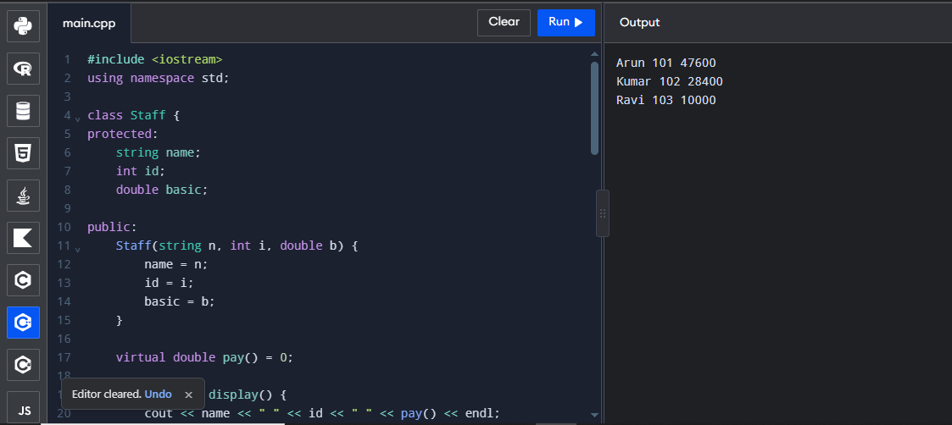

TASK 2 – FROM REQUIREMENT TO HIERARCHY
Bloom’s Level: K5 – Evaluate
University People Management
8 Marks
A university keeps records of persons (name, ID, phone). Students have a programme and
CGPA; staff have a department and salary. A teaching assistant is both a student and a staff
member. Research scholars are students who also hold a fellowship.
Task 2.1 – Identify the Relationships | 2 Marks
Classify each relationship as is-a (inheritance) or has-a (member class), and name the type of
inheritance (single, multiple, multilevel, hierarchical, hybrid) used for each part.

Task 2.2 – Resolve the Diamond | 2 Marks
Explain the problem that arises when TeachingAssistant inherits from both Student and Staff,
and how virtual base classes solve it.
Task 2.3 – Design the Classes | 3 Marks
Write the class declarations with access specifiers, and decide for each base class whether it
is inherited publicly, protectedly or privately.
Task 2.4 – Access Table | 1 Mark
Prepare a table showing how a public, protected and private member of Person is visible in
Student under public, protected and private inheritance.
Predict the Output
Write the exact output of the program below BEFORE running it. Then compile and run it,
and explain every difference between your prediction and the actual output.

Program:
#include <iostream>
using namespace std;

class Person {
public:
Person() {
cout << "Person ";
}
};

class Student : virtual public Person {
public:
Student() {
cout << "Student ";
}
};

class Staff : virtual public Person {
public:
Staff() {
cout << "Staff ";
}
};

class TeachingAssistant : public Student, public Staff {
public:
TeachingAssistant() {
cout << "TA ";
}
};

int main() {
TeachingAssistant ta;
cout << endl;

return 0;
}
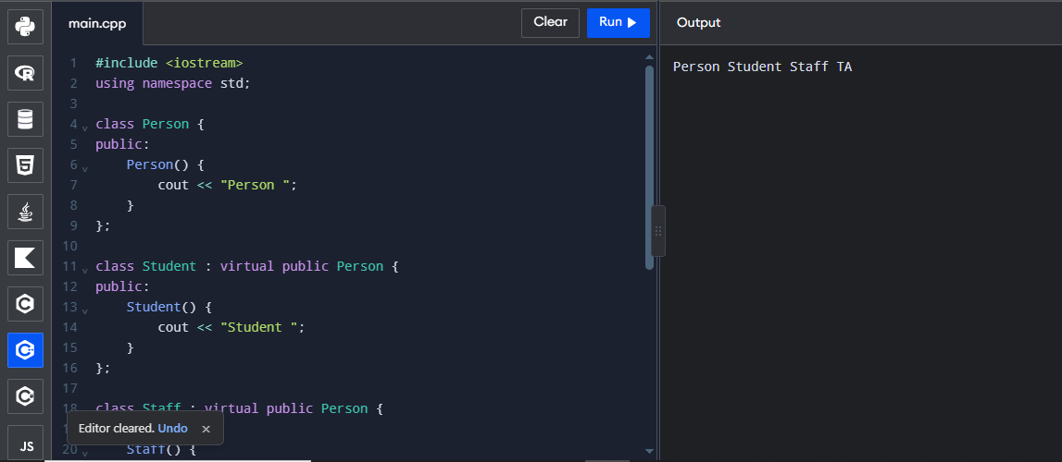

TASK 3 – CONSTRUCTORS IN DERIVED CLASSES AND MEMBER CLASSES
Bloom’s Level: K5 – Evaluate
Order of Construction and Destruction
9 Marks
Task 3.1 – Pass Values to Base Constructors | 3 Marks
Write constructors for Student, Staff and TeachingAssistant that pass values to their base
classes through initializer lists. Explain why the most-derived class must call the virtual base
constructor directly.
Task 3.2 – Member Classes | 2 Marks
Add an Address member class to Person and a Course member class to Student. Show how
their constructors receive values.
Task 3.3 – Trace the Order | 3 Marks
Print a message in every constructor and destructor and record the order for a Student, a Staff
and a TeachingAssistant object. Explain the rule you observe.
Task 3.4 – Experiment | 1 Mark
Remove the virtual keyword from the base classes and record how the output and
sizeof(TeachingAssistant) change.
Predict the Output

Write the exact output of the program below BEFORE running it. Then compile and run it,
and explain every difference between your prediction and the actual output.

Program 1:
#include <iostream>
using namespace std;

class Engine {
public:
Engine() {
cout << "Engine ";
}

~Engine() {
cout << "~Engine ";
}
};

class Vehicle {
public:
Vehicle() {
cout << "Vehicle ";
}

~Vehicle() {
cout << "~Vehicle ";
}
};

class Car : public Vehicle {
Engine e;

public:
Car() {
cout << "Car ";
}

~Car() {
cout << "~Car ";
}
};

int main() {
{
Car c;
cout << "| ";
}

cout << endl;
return 0;
}
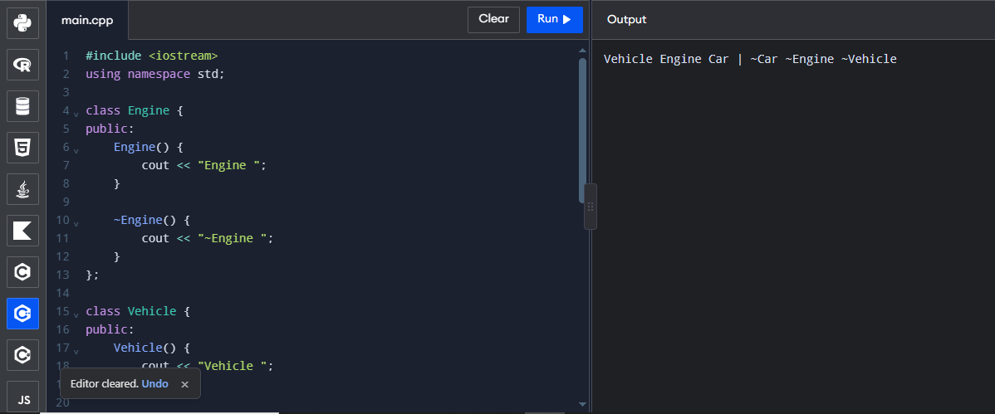

Program 2:
#include <iostream>
#include <string>
using namespace std;

class Person {
protected:
string name;
int age;

public:
Person(string n, int a) : name(n), age(a) {}
};

class Address {
string city;
int pin;

public:
Address(string c, int p) : city(c), pin(p) {}

string str() const {
return city + "-" + to_string(pin);
}
};

class Student : public Person {
long long regNo;
Address home;

public:
Student(string n, int a, long long r, string c, int p)
: Person(n, a), regNo(r), home(c, p) {}

void print() {
cout << regNo << " " << name << " ("
<< age << ") " << home.str() << endl;
}
};

int main() {
Student s("Kavya", 19, 192311001, "Salem", 636001);
s.print();

return 0;
}
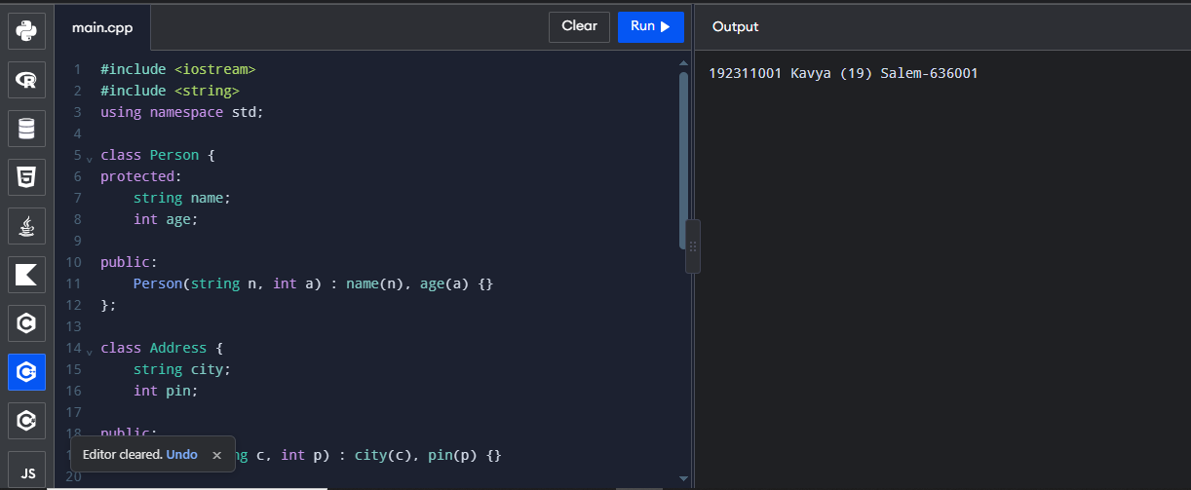

TASK 4 – POINTERS TO DERIVED CLASSES: FORENSICS
Bloom’s Level: K5 – Evaluate
7 Marks
A bank stores different kinds of accounts through base-class pointers. Senior-citizen accounts
should earn 4.0% interest, but every account earns 3.5%, and memory reports show that part
of each senior account is never released.
class Account { public: double rate() const { return 3.5; } ~Account() {} };
class SeniorAccount : public Account {
double* history = new double[100];
public: double rate() const { return 4.0; } ~SeniorAccount() { delete[] history; } };

Account* accounts[2] = { new Account, new SeniorAccount };
for (Account* a : accounts) std::cout << a->rate() << "\n";
for (Account* a : accounts) delete a;
Account copy = SeniorAccount(); // stored in a vector<Account> elsewhere

Task 4.1 – Locate the Defects | 2 Marks
Identify why the senior rate is never used, why memory leaks, and what object slicing does in
the last line.
Task 4.2 – Construct Evidence | 2 Marks
Run the program under -fsanitize=address and add output to the destructors to prove each
defect.
Task 4.3 – Repair the Program | 2 Marks

Correct the program using virtual functions, a virtual destructor and pointers (or references)
instead of copies.
Task 4.4 – Prevent Recurrence | 1 Mark
State two rules that would have prevented these defects (for example: a base class with
virtual functions needs a virtual destructor; use override).
Predict the Output
Write the exact output of the program below BEFORE running it. Then compile and run it,
and explain every difference between your prediction and the actual output.

Program:
#include <iostream>
using namespace std;

class Account {
public:
double rate() const {
return 3.5;
}

virtual double vrate() const {
return 3.5;
}

virtual ~Account() {}
};

class SeniorAccount : public Account {
public:
double rate() const {
return 4.0;
}

double vrate() const override {
return 4.0;
}
};

int main() {
SeniorAccount s;
Account* p = &s;

Account copy = s;

cout << p->rate() << " "
<< p->vrate() << " "
<< copy.vrate() << endl;

return 0;
}
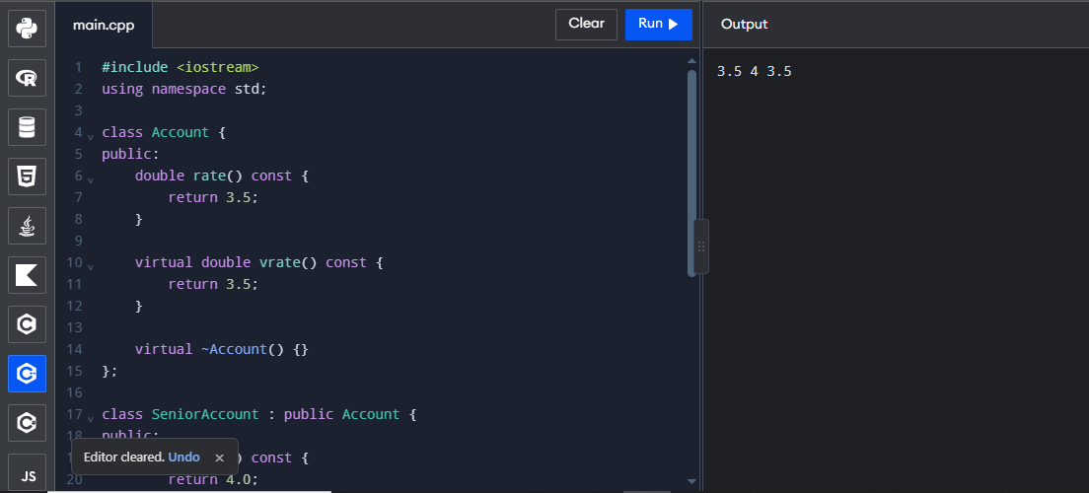

TASK 5 – POINTERS TO OBJECTS AND THE this POINTER
Bloom’s Level: K5 – Evaluate
7 Marks
A grocery delivery app keeps a shopping Cart object for each customer.
Task 5.1 – Four Ways to Reach an Object | 3 Marks
Write code that uses a Cart (a) directly by name, (b) through a pointer with ->, (c) through a
reference, and (d) through a pointer created with new and released with delete. Use the this
pointer to return *this so that calls can be chained, and to separate a member from a
parameter with the same name.
Task 5.2 – Change the Requirement | 2 Marks
The app now keeps an array of pointers to Cart objects for all active customers. Write code
that finds the cart with the highest total using pointer arithmetic or indexing.
Task 5.3 – Compare | 2 Marks
Compare the four ways on safety, lifetime and when each should be used. Explain why this is
a pointer and what *this refers to.

Program:
#include <iostream>
#include <iomanip>
#include <string>
using namespace std;

class Cart {
string items[10];
double prices[10];
int n = 0;
double discount = 0;

public:
Cart& add(string item, double price) {
if (n < 10) {
items[n] = item;
prices[n] = price;
n++;
}
return *this;
}

Cart& setDiscount(double discount) {
this->discount = discount;
return *this;
}

double total() const {
double t = 0;

for (int i = 0; i < n; i++)
t += prices[i];

return t * (100 - discount) / 100;
}
};

int main() {
Cart c;

c.add("Rice", 60)
.add("Dal", 120)
.setDiscount(10);

Cart* p = &c;

p->add("Oil", 180);

cout << fixed << setprecision(2)
<< p->total() << endl;

return 0;
}
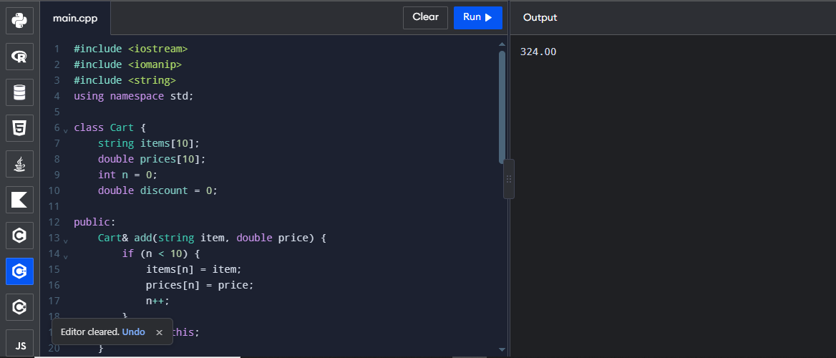

TASK 6 – DESIGN CHALLENGE
Bloom’s Level: K5 – Evaluate
Vehicle Rental Fleet
13 Marks
A rental company rents bicycles, two-wheelers, cars and electric cars. All vehicles have a
registration number and a daily rate. Motor vehicles also have a fuel or charge level and a
service due date; cars have a seating capacity; electric cars have a battery capacity and are
charged per kWh instead of per litre. Each vehicle computes its rental charge differently. The
company needs to rent, return and list vehicles, and to add new vehicle types in future
without changing the existing classes.
You are not given the design.
Stage 1 – Interpret the Problem | 2 Marks

Identify the entities, their data and the behaviour that differs between them. State the
requirements as testable statements.
Stage 2 – Propose the Hierarchy | 2 Marks
Draw the class hierarchy, showing an abstract base class with at least one pure virtual
function, the types of inheritance and any member classes.
Stage 3 – Identify the Critical Design Decisions | 2 Marks
Decide what is placed in each class, which functions are virtual, and how the fleet is stored
(an array of base-class pointers).
Stage 4 – Design the Classes | 4 Marks
Present the class declarations and pseudocode for renting and returning a vehicle.
Stage 5 – Implement and Demonstrate | 3 Marks
Implement the program and demonstrate renting each type, returning with a late charge, and
adding a new vehicle type (for example an electric bus) without changing the existing classes.
Alternative Concept and Complexity Analysis
If the fleet used a single Vehicle class with a type code and a switch in charge() instead of an
abstract base class with virtual functions, what would the solution be? Analyse the time per
charge() call (a switch versus a virtual call, both O(1)), the space per object (unused fields
versus one vtable pointer), and the classes changed when a new vehicle type is added.
Evidence Expected
A complete hierarchy design with pseudocode, a working program and a demonstrated
extension.

Program:
#include <iostream>
#include <string>
using namespace std;

class Vehicle {
protected:
string regNo;
double rate;
bool rented;

public:
Vehicle(string r, double d) {
regNo = r;
rate = d;
rented = false;
}

virtual double charge(int days) = 0;

void rent() {
if (!rented) {
rented = true;
cout << regNo << " rented successfully" << endl;
}
else {
cout << regNo << " already rented" << endl;
}
}

void giveBack(int days) {
if (rented) {
cout << regNo << " returned. Amount: Rs."
<< charge(days) << endl;
rented = false;
}
else {
cout << regNo << " is not rented" << endl;
}
}

virtual void display() = 0;

virtual ~Vehicle() {}
};

class Bicycle : public Vehicle {
public:
Bicycle(string r, double d) : Vehicle(r, d) {}

double charge(int days) override {
return rate * days;
}

void display() override {
cout << "Bicycle: " << regNo << endl;
}
};

class TwoWheeler : public Vehicle {
public:
TwoWheeler(string r, double d) : Vehicle(r, d) {}

double charge(int days) override {
return rate * days;
}

void display() override {
cout << "Two Wheeler: " << regNo << endl;
}
};

class Car : public Vehicle {
public:
Car(string r, double d) : Vehicle(r, d) {}

double charge(int days) override {
return rate * days;
}

void display() override {
cout << "Car: " << regNo << endl;
}
};

class ElectricCar : public Vehicle {
public:
ElectricCar(string r, double d) : Vehicle(r, d) {}

double charge(int days) override {
return rate * days + 100;
}

void display() override {
cout << "Electric Car: " << regNo << endl;
}
};

int main() {
Vehicle* fleet[4];

fleet[0] = new Bicycle("TN01", 100);
fleet[1] = new TwoWheeler("TN02", 200);
fleet[2] = new Car("TN03", 1000);
fleet[3] = new ElectricCar("TN04", 1200);

for (int i = 0; i < 4; i++) {
fleet[i]->display();
fleet[i]->rent();
fleet[i]->giveBack(2);
cout << endl;
}

for (int i = 0; i < 4; i++) {
delete fleet[i];
}

return 0;
}


